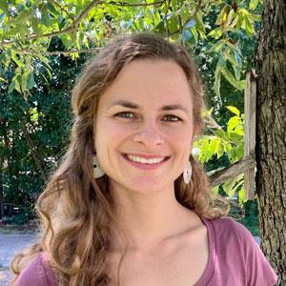
Judith Menzl
Tree Inventory Technician

BACKGROUND
Judith has a background in conservation work and tree care in both the private and public sector. She found her passion in conservation and urban forestry after joining the Texas Conservation Corps in 2017 for a year of service. While there, she worked on various projects ranging from disaster response and hazardous tree removal to watershed and forest management. Prior to joining PlanIT Geo, Judith was a production tree climber for several years and also worked in the Parks and Recreation Department at the City of Austin managing and inventorying public park trees.

At PlanIT Geo, Judith is a Tree Inventory Technician collecting and managing tree inventory data. She is also working towards a GIS certification at the Austin Community College in Texas.

EDUCATION
Master of Arts in German Studies, Translation Emphasis | University of Arizona, 2017

Bachelor of Arts in Linguistics, Minor in Molecular and Cellular Biology | University of Arizona, 2015

PROFESSIONAL CERTIFICATIONS
ISA Certified Arborist #TX-4751A (Austin, TX 2021)

ISA Tree Risk Assessment Qualification (Austin, TX 2022)

RELEVANT PROJECTS
Colonie, NY - Inventory - 2022
Served as a tree inventory technician to map, evaluate, and perform risk assessments on trees within town boundaries.
(https://pg-cloud.com/ColonieNY)

Orlando, FL - Inventory - 2022
Served as a tree inventory technician to map and evaluate trees on city property.
(https://pg-cloud.com/OrlandoFL/)

