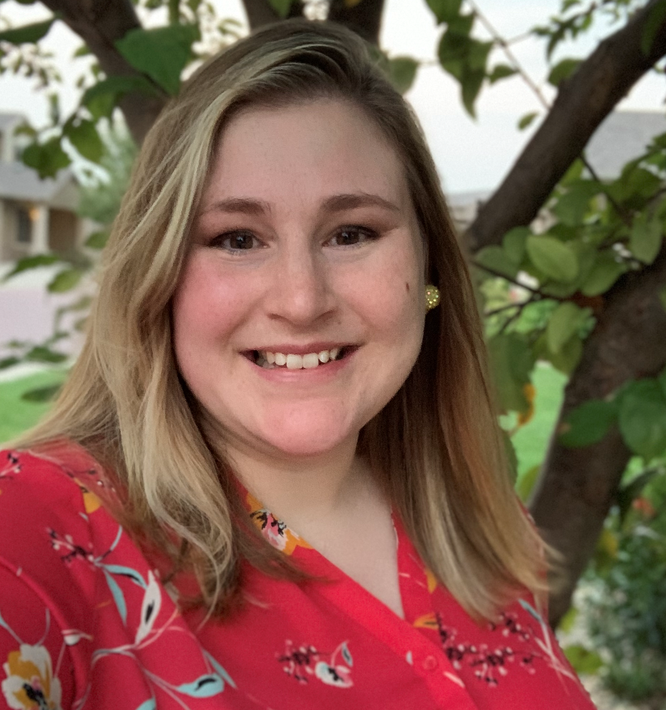
Appendix I. Consulting Team Resumes

Rachel Ormseth
Urban Forestry Consultant, PlanIT Geo
Professional Summary
Rachel specializes in urban and community forestry planning, management, development, and innovation. Rachel has extensive experience in working with communities, big and small, to manage their city trees in a sustainable and effective manner. Rachel has administered Urban Forestry programs from a state level and has led a team of three urban foresters for work on the ground. Rachel is experienced in the collection of tree inventory data, tree selection, multi-organization project management, and coordination of partnerships for resource sharing.
With five years of public service, Rachel has come to understand and effectively navigate the facets of Urban Forestry in cities where funding and resources are sparse. Rachel knows that successful collaboration can only be achieved when a personal relationship is formed with the client and the client’s individual situation is assessed. Through this relationship, the client can receive the proper guidance and tools for a successful project.
Education
Bachelor of Agricultural Science, Biology and Horticulture- South Dakota State University (2016)
Professional Certifications
Certified Arborist, International Society of Arboriculture (MW-5815A)
Graduate of 2019 Municipal Forestry Institute (MFI)

Relevant Skills and Expertise
Urban Forestry Consultant, PlanIT Geo (2021 – Present)
As an Urban Forestry Consultant, Rachel provides urban forestry services for communities, organizations, and private firms. Her expertise includes urban and community forestry management, planning, software, and innovation. In this role, Rachel works with small and large communities, statewide agencies, and non-profit organizations to enhance urban forest management through projects such as strategic tree planting, tree inventories, management plans, canopy plans, tree conservation and restoration, tree and maintenance specs and ordinances, and regional planning.

Relevant Projects
Kirkwood, MO Urban Forest Master Plan (In progress): Rachel will be guiding the phases of the planning process. This includes a research deep dive, conducting project planning meetings, community engagement, staff engagement, creation of the project’s website, inventory analysis, maintenance prioritization, and eco-benefits analysis. The results of the planning include guidance for and impacts of multiple management scenarios and recommended management approach to achieve long-term goals for sustainability.
Los Banos, CA Tree Inventory and Urban Forest Management Plan (In progress): Rachel is assisting with various phases of constructing the management plan including staff surveys, inventory analysis, program benchmarking, maintenance scheduling and budgeting.
North Tonawanda, NY Tree Inventory and Urban Forest Management Plan (In progress): Rachel is assisting with various phases of constructing the North Tonawanda Urban Forest Management Plan from auditing the city’s current programs and policies, analyzing inventory data, and drafting staff surveys.
Renton, WA Urban Forest Management Plan (In progress): This Urban Forest Management Plan 10-year update provides the framework for enhancing the City’s Urban Forestry & Natural Resources Division’s levels of service as it relates to the management of the urban forest and meeting community goals. The planning process includes an extensive analysis of the existing conditions and operations by using the U.S. Forest Service’s Urban Forest Sustainability and Management Audit. The Audit is informed by information gathering via city staff interviews, public surveys, data analyses, and benchmarking research. Project includes extensive review of City Code and policies to provide recommendations. Includes a project website (www.RentonForestryPlan.com) and project branding “Rooted in Renton”, engaging the public to inform the plan.

Schenectady, NY Tree Inventory and Urban Forest Management Plan (In progress): Rachel will be guiding the phases of the planning process. This includes an extensive analysis of the existing conditions and operations by using the U.S. Forest Service’s Urban Forest Sustainability and Management Audit. The Audit is informed by information gathering via city staff interviews, public meetings, data analyses, and benchmarking research. The results of the planning include guidance for and impacts of multiple management scenarios and recommended management approach to achieve long-term goals for sustainability. The plan will also contain a supplemental planting plan and storm preparedness grant.

